 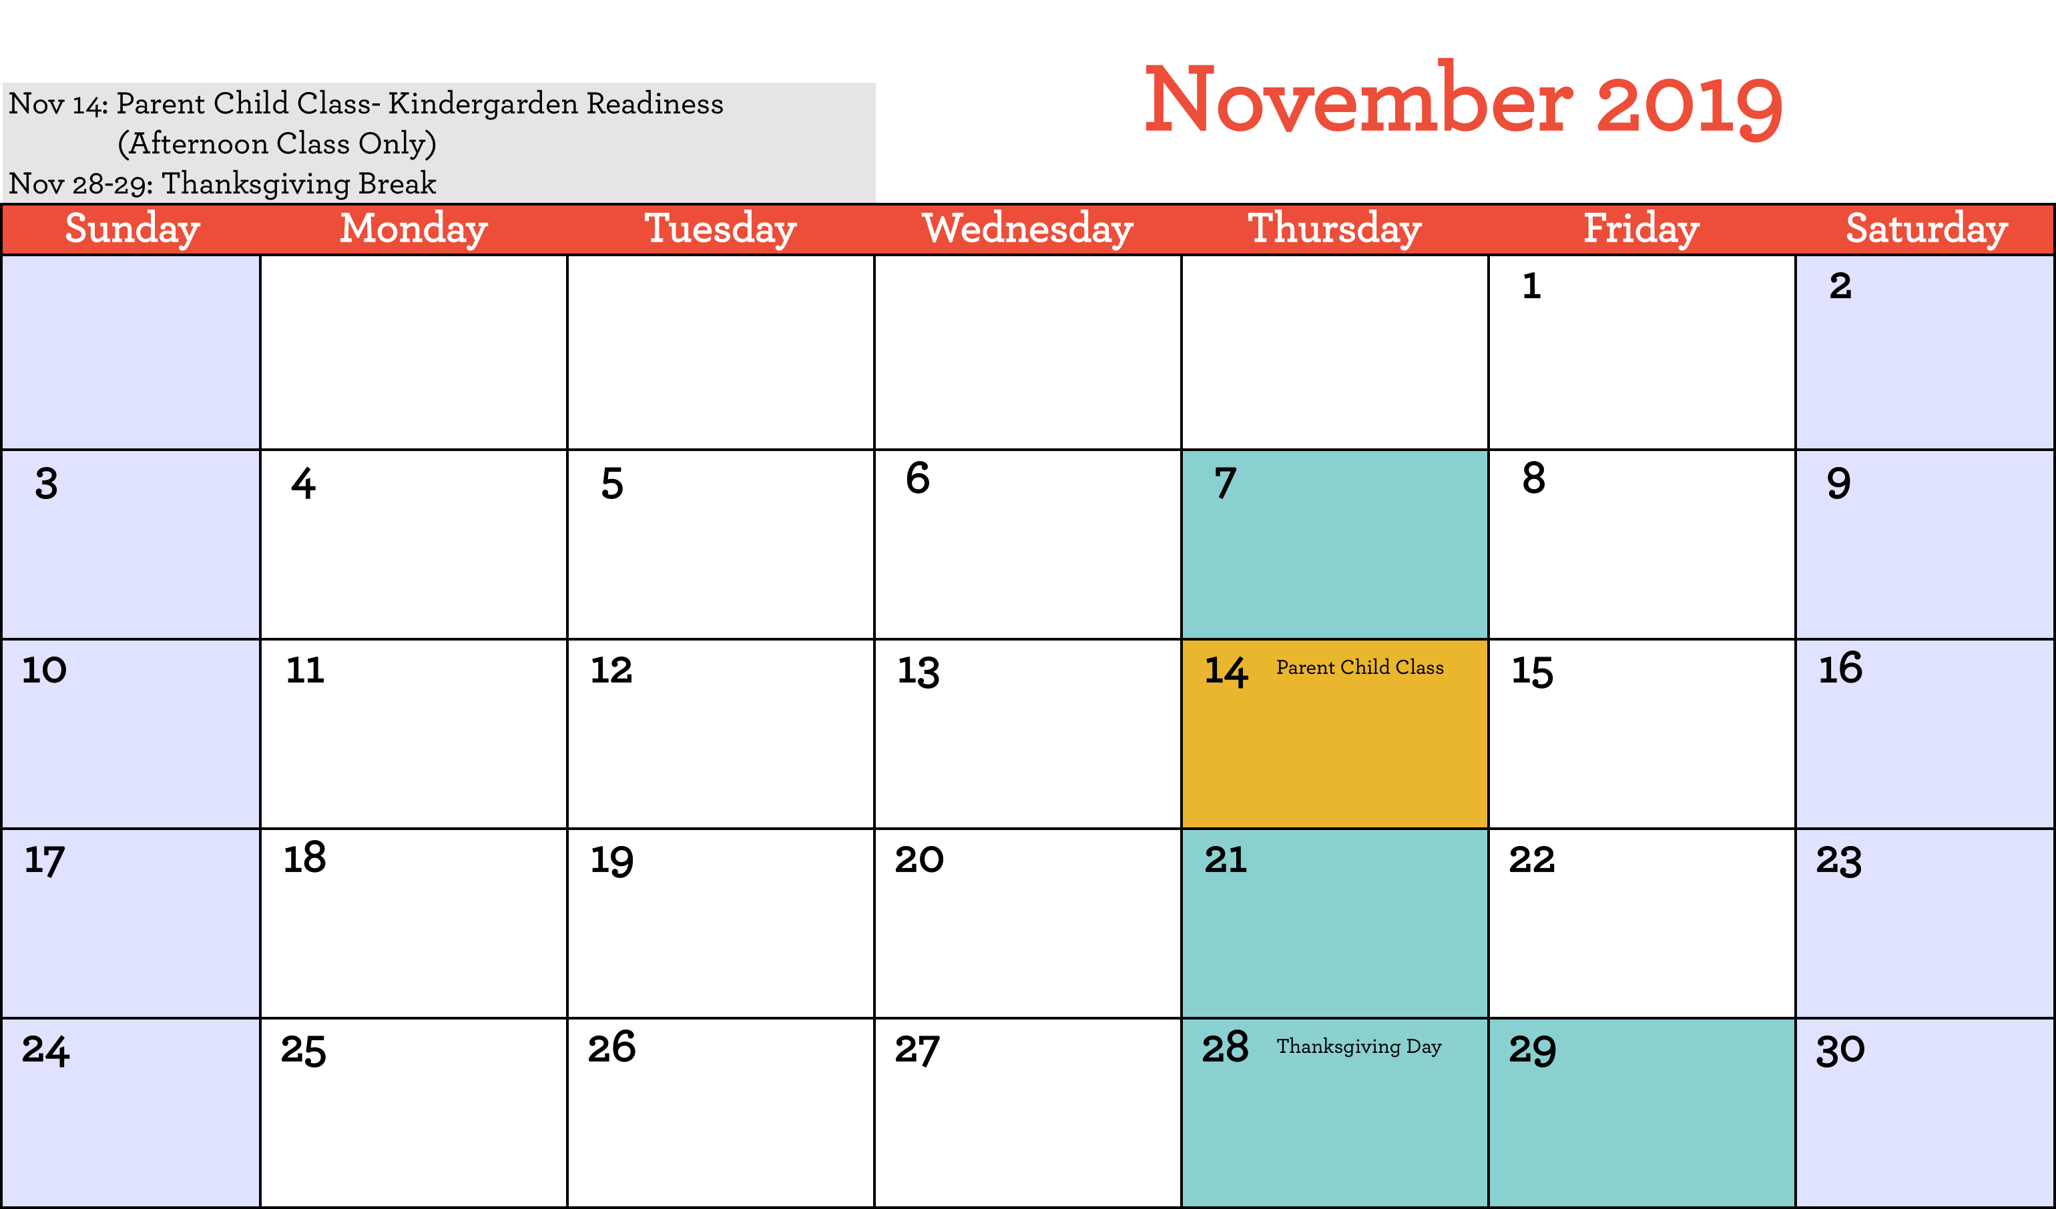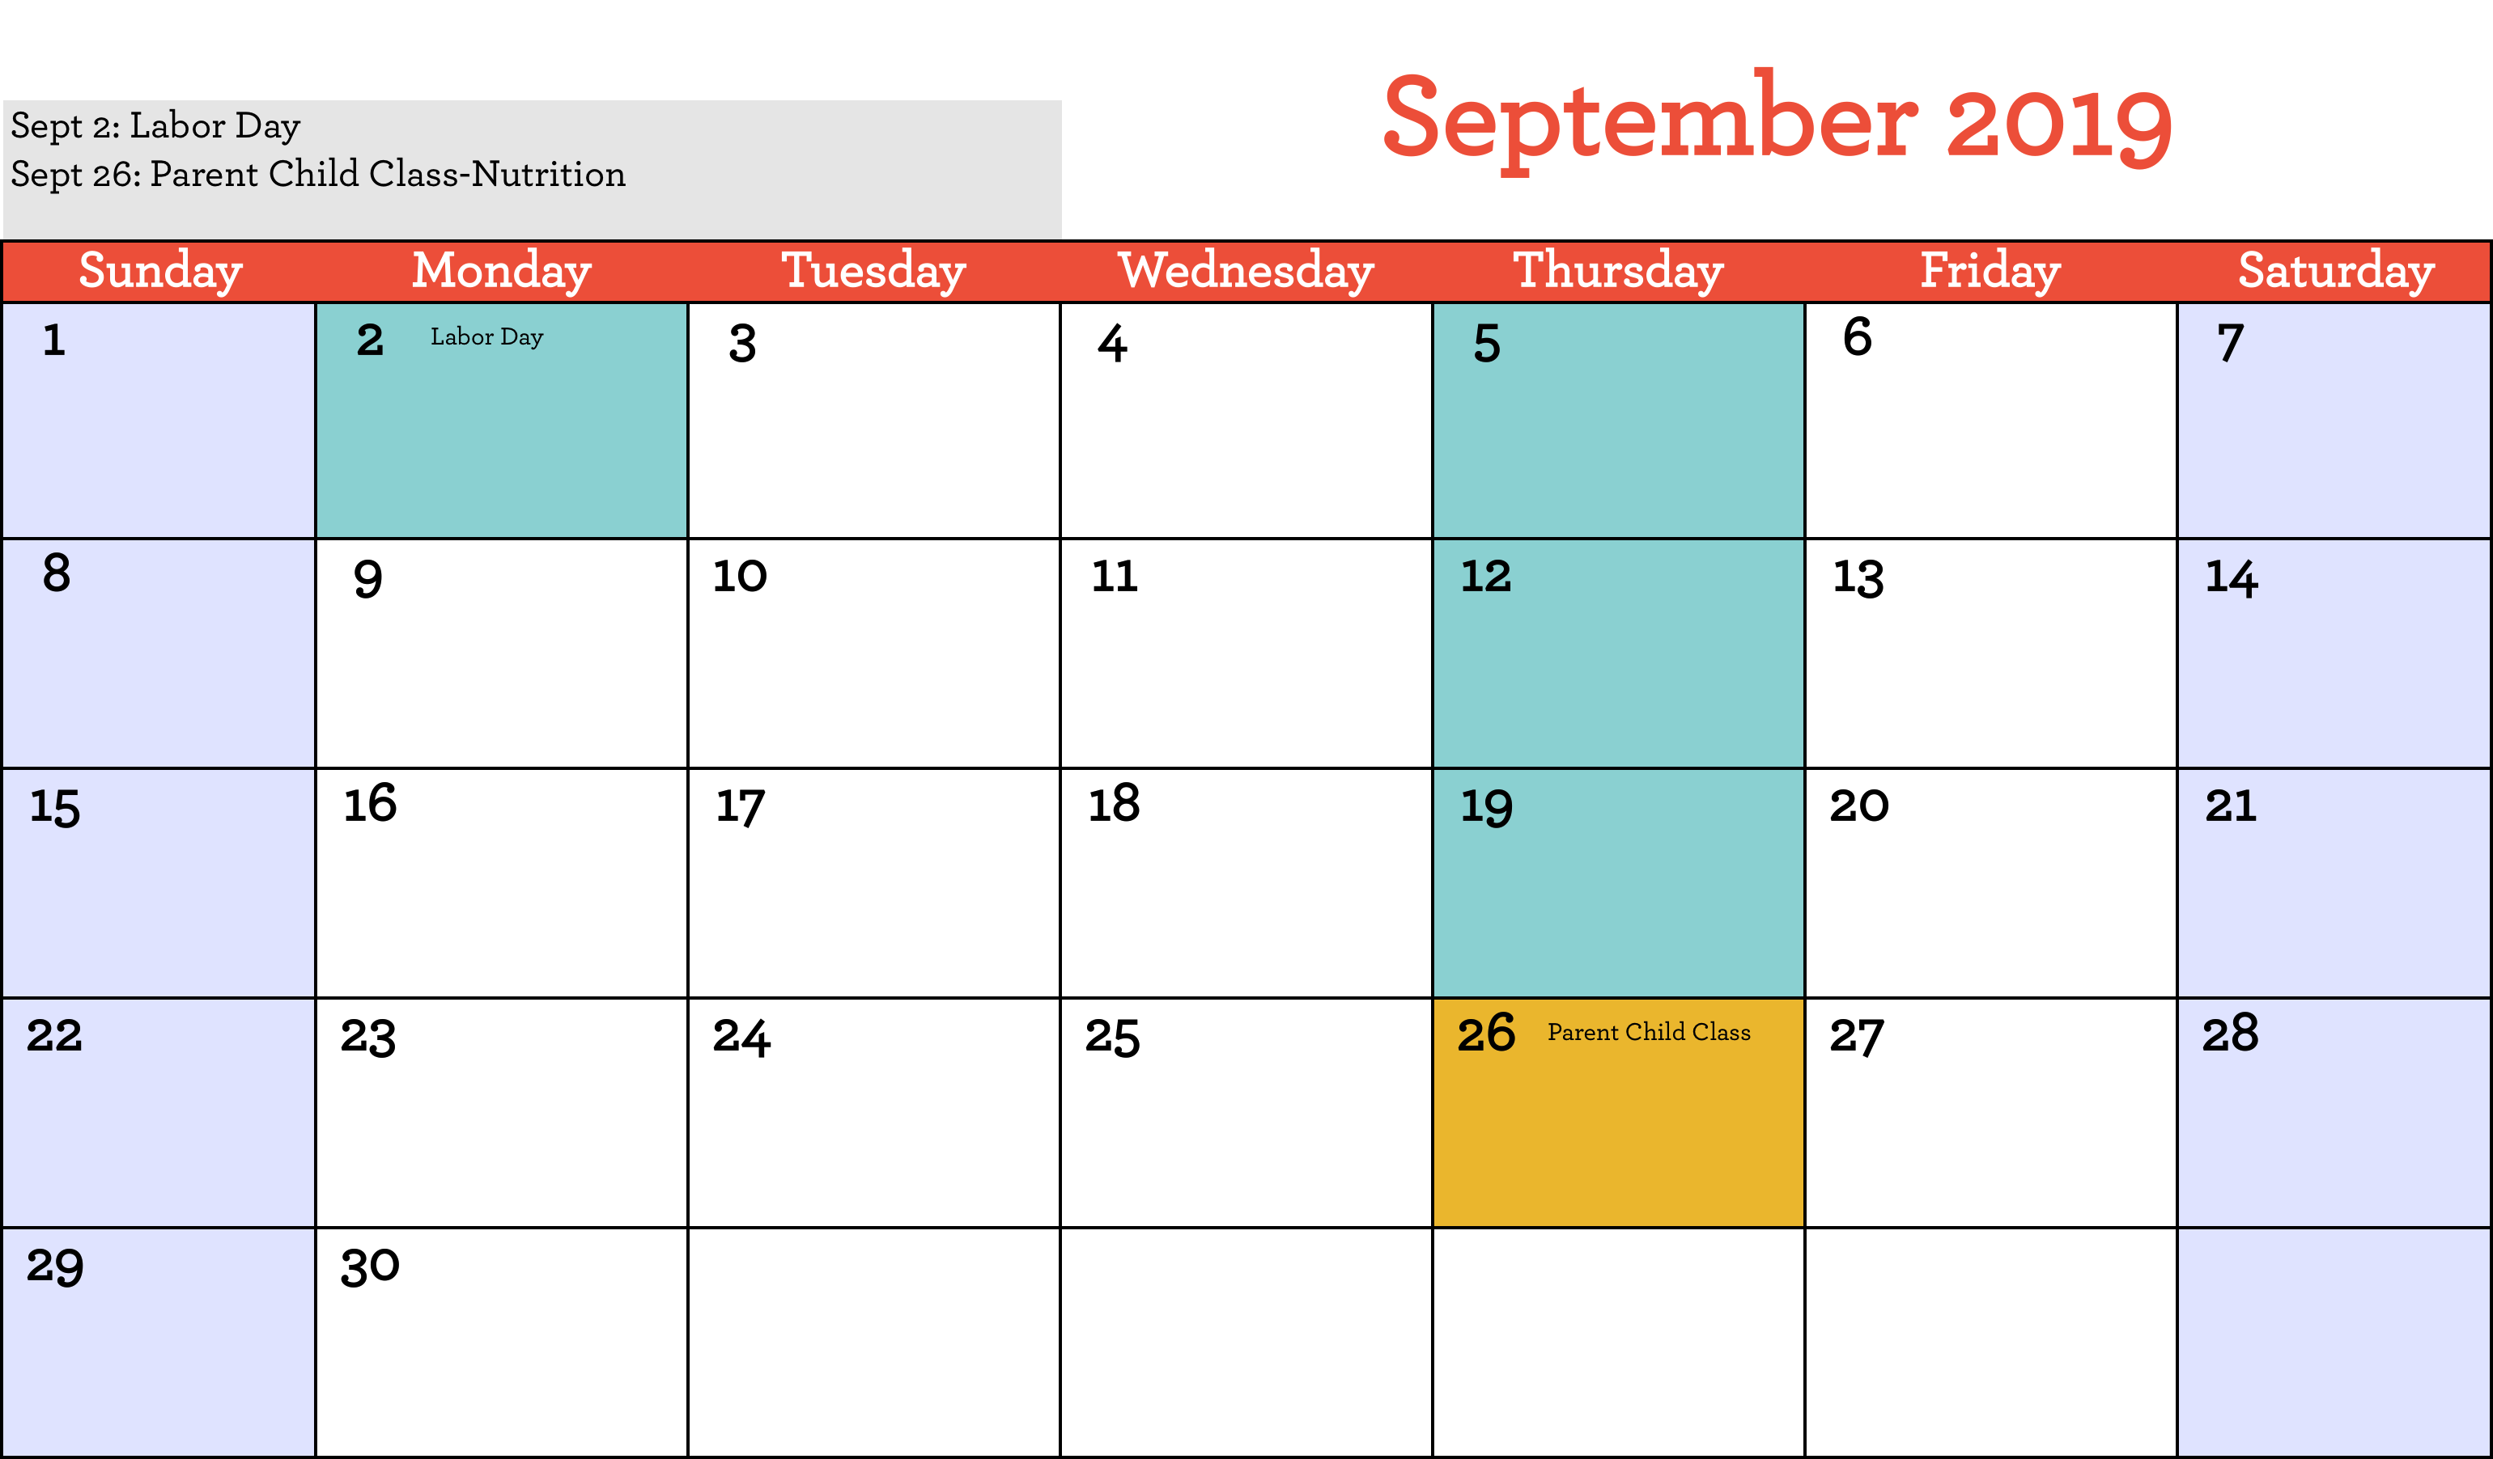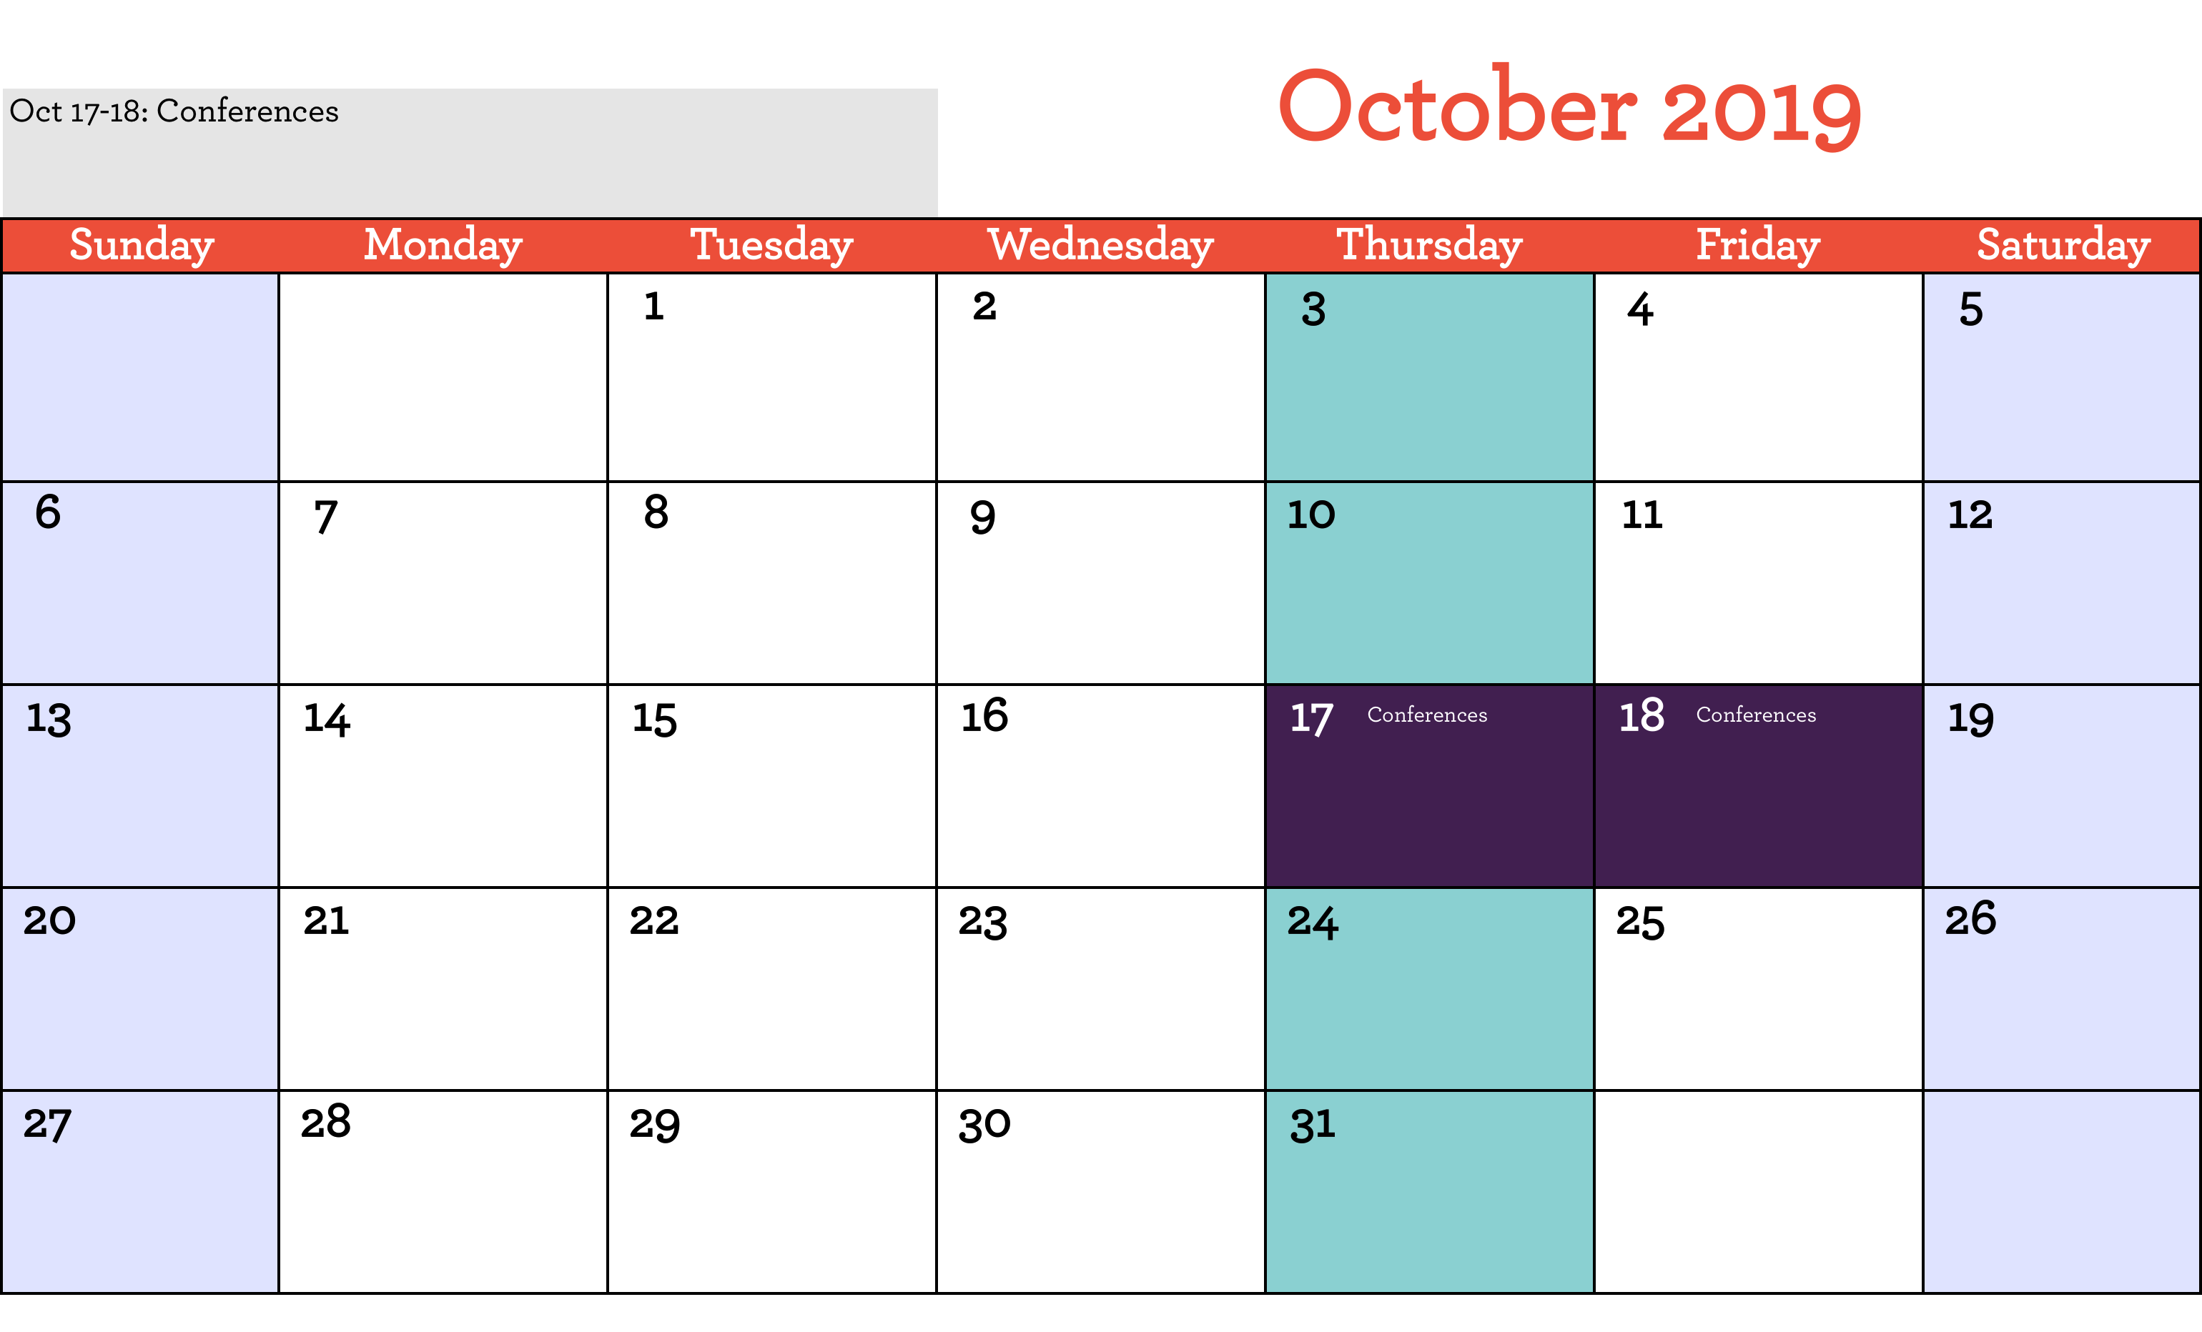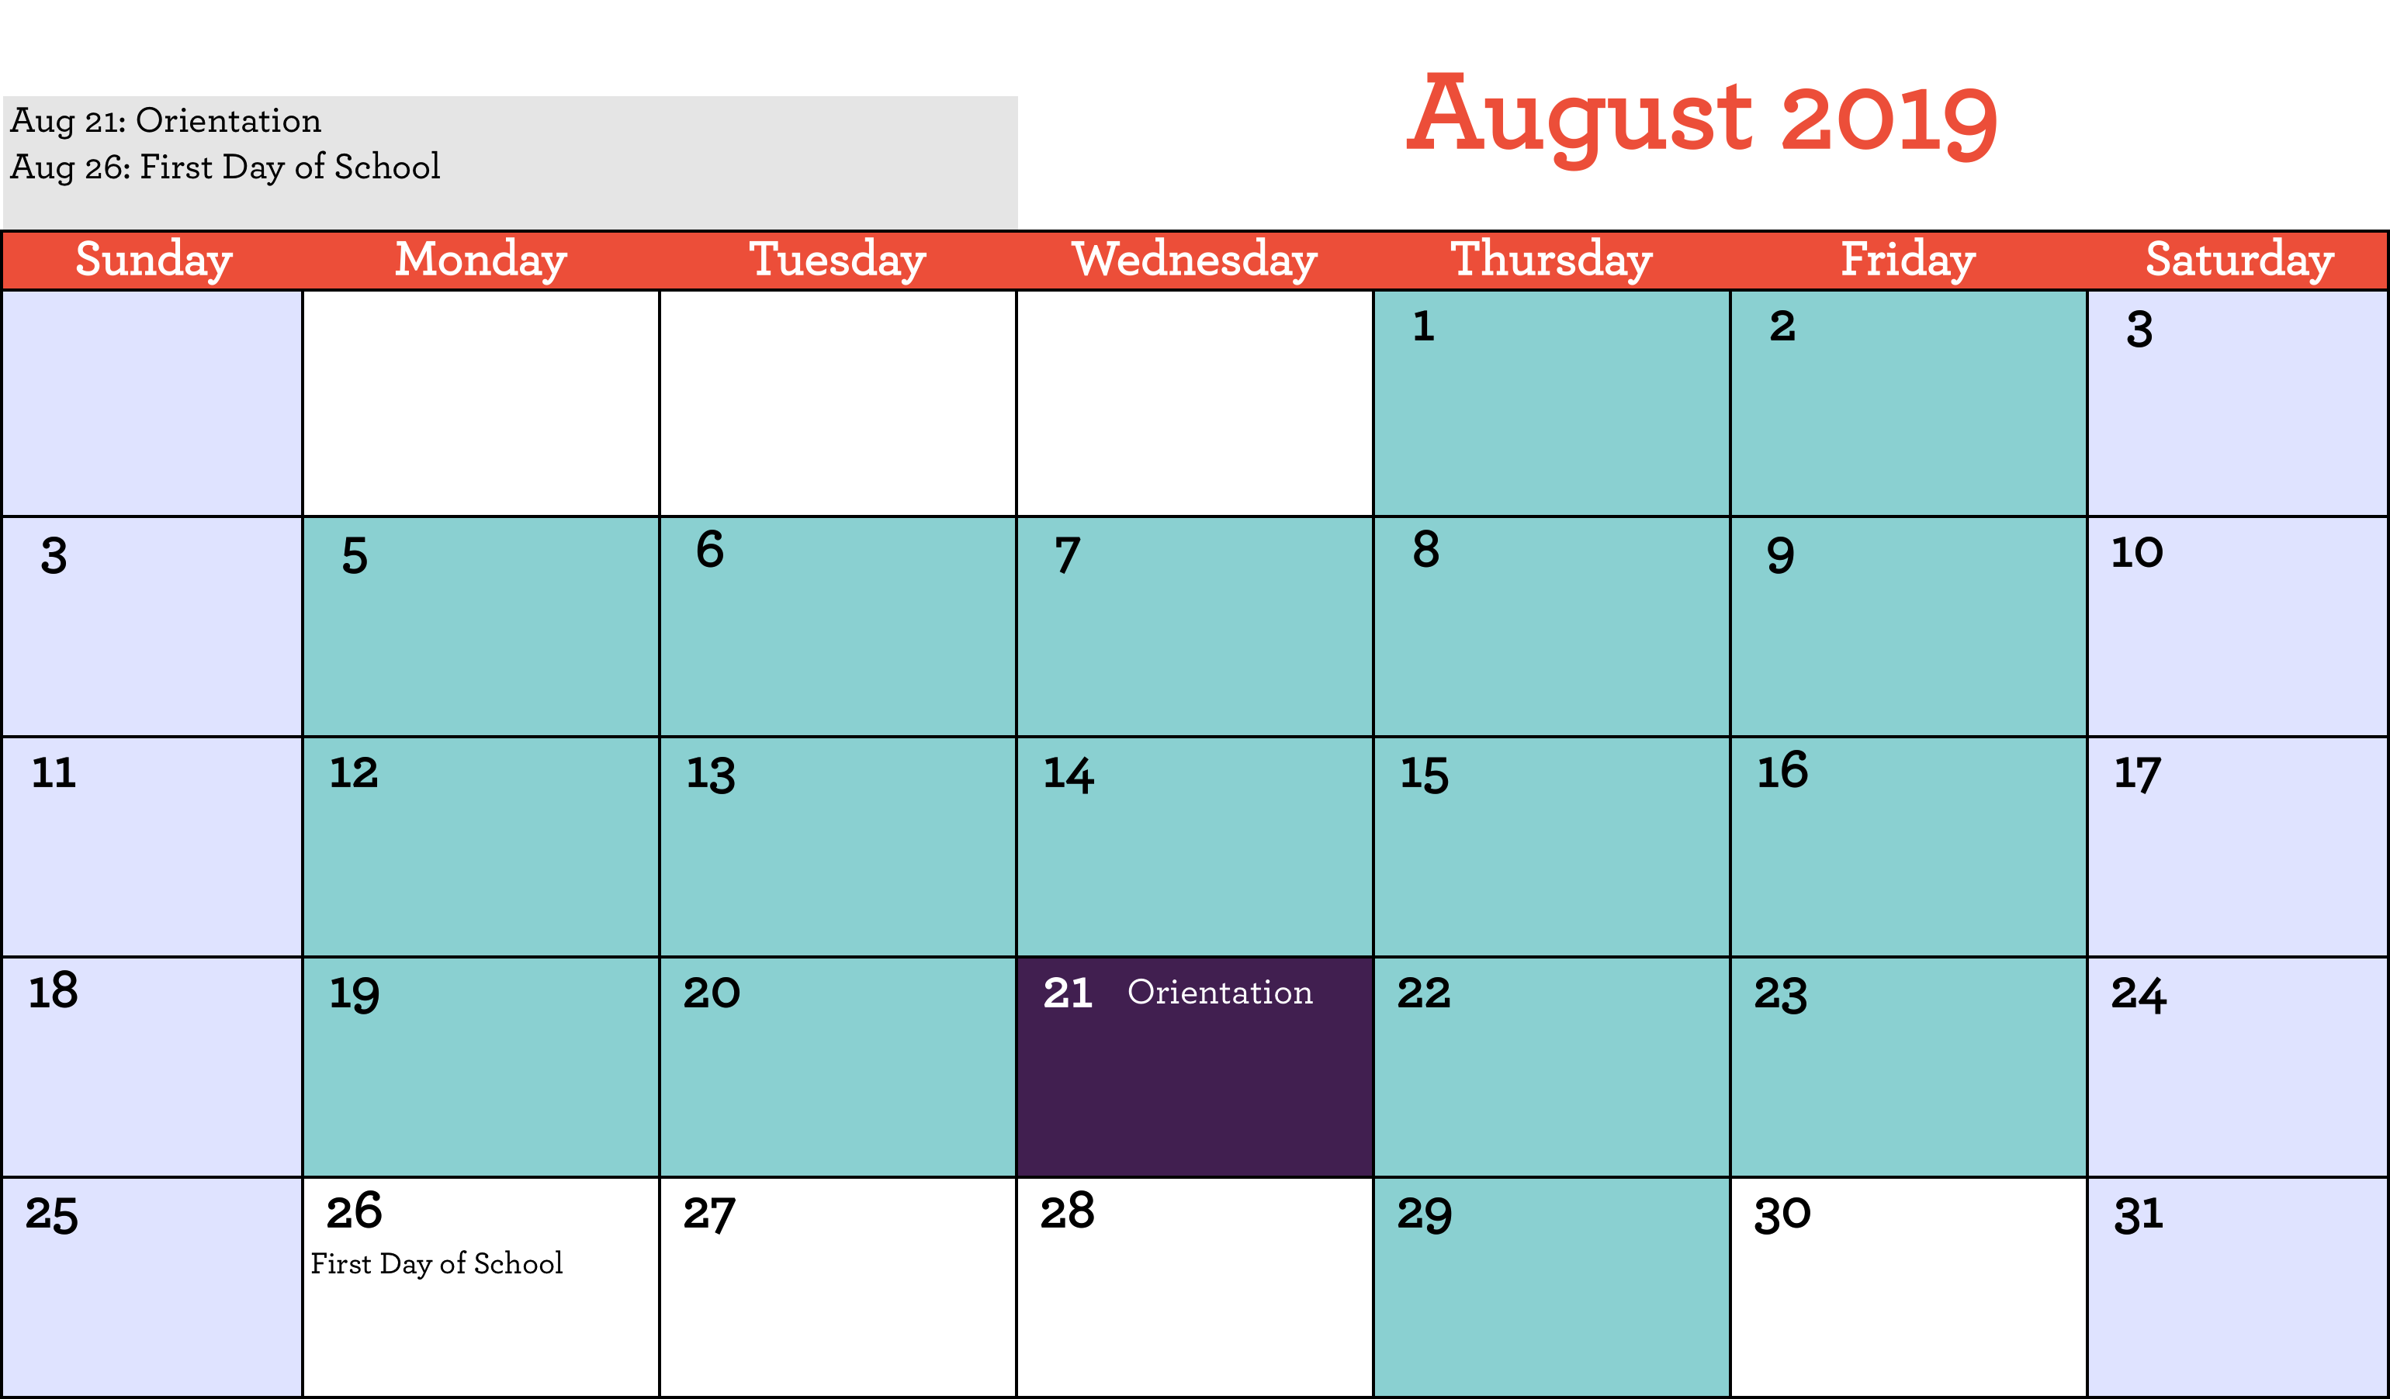

Preschool Pals Staff:

Eka Nagoya, Lead Teacher 612.558.6562

Alanna Welsh, Assistant Teacher

Daniela Brito, Classroom Aide

Willie Lane, Bus Driver

Information:

Way to Grow office: 612.874.4740

Preschool Pals: 612.558.6562

Hours of Operation:

AM class: 8:00 am – 10:30 am

PM class: 12:30 pm – 4:15 pm

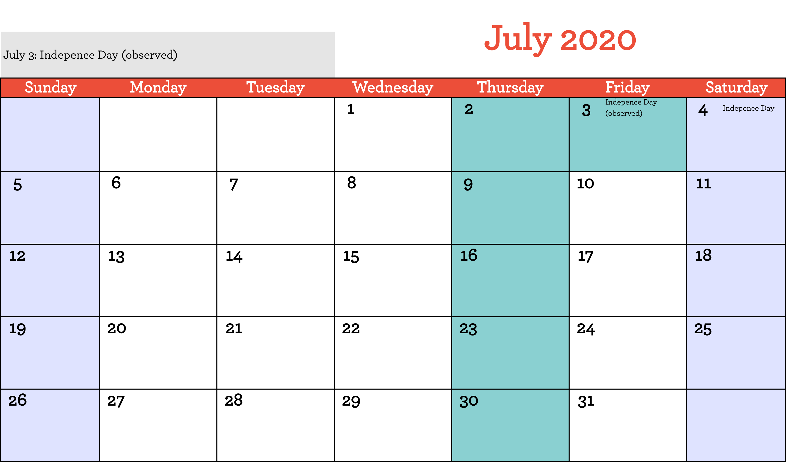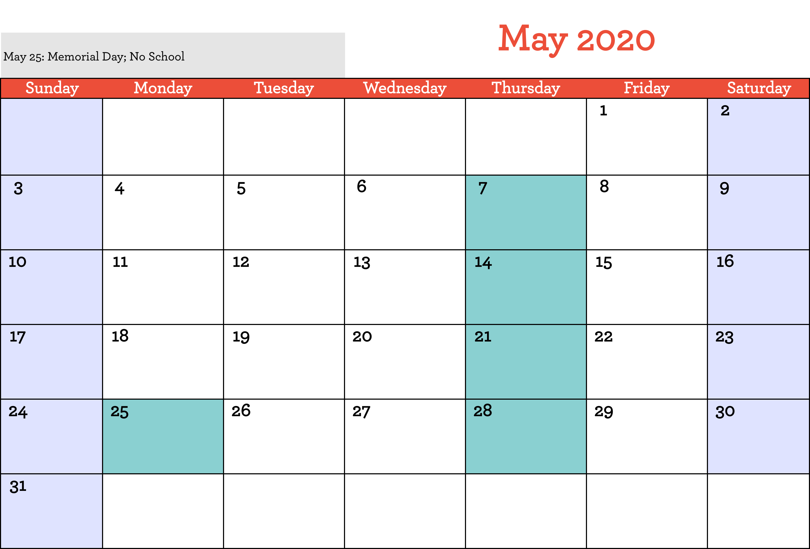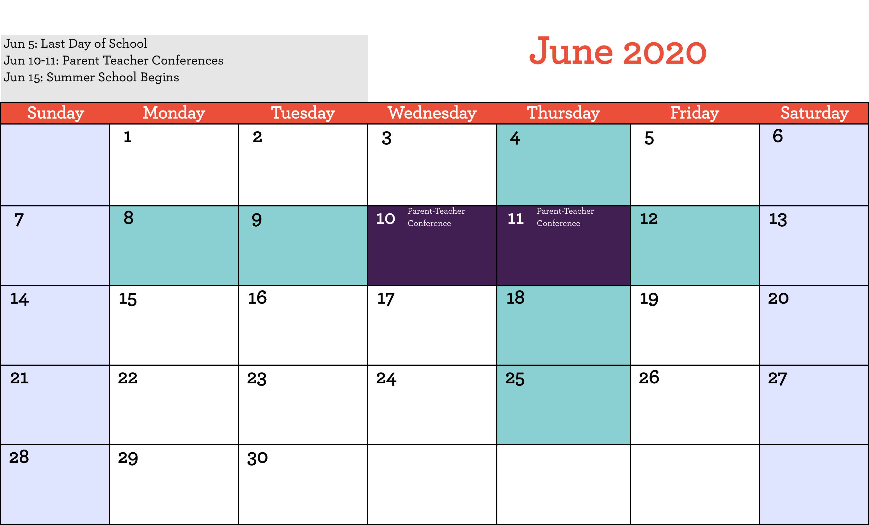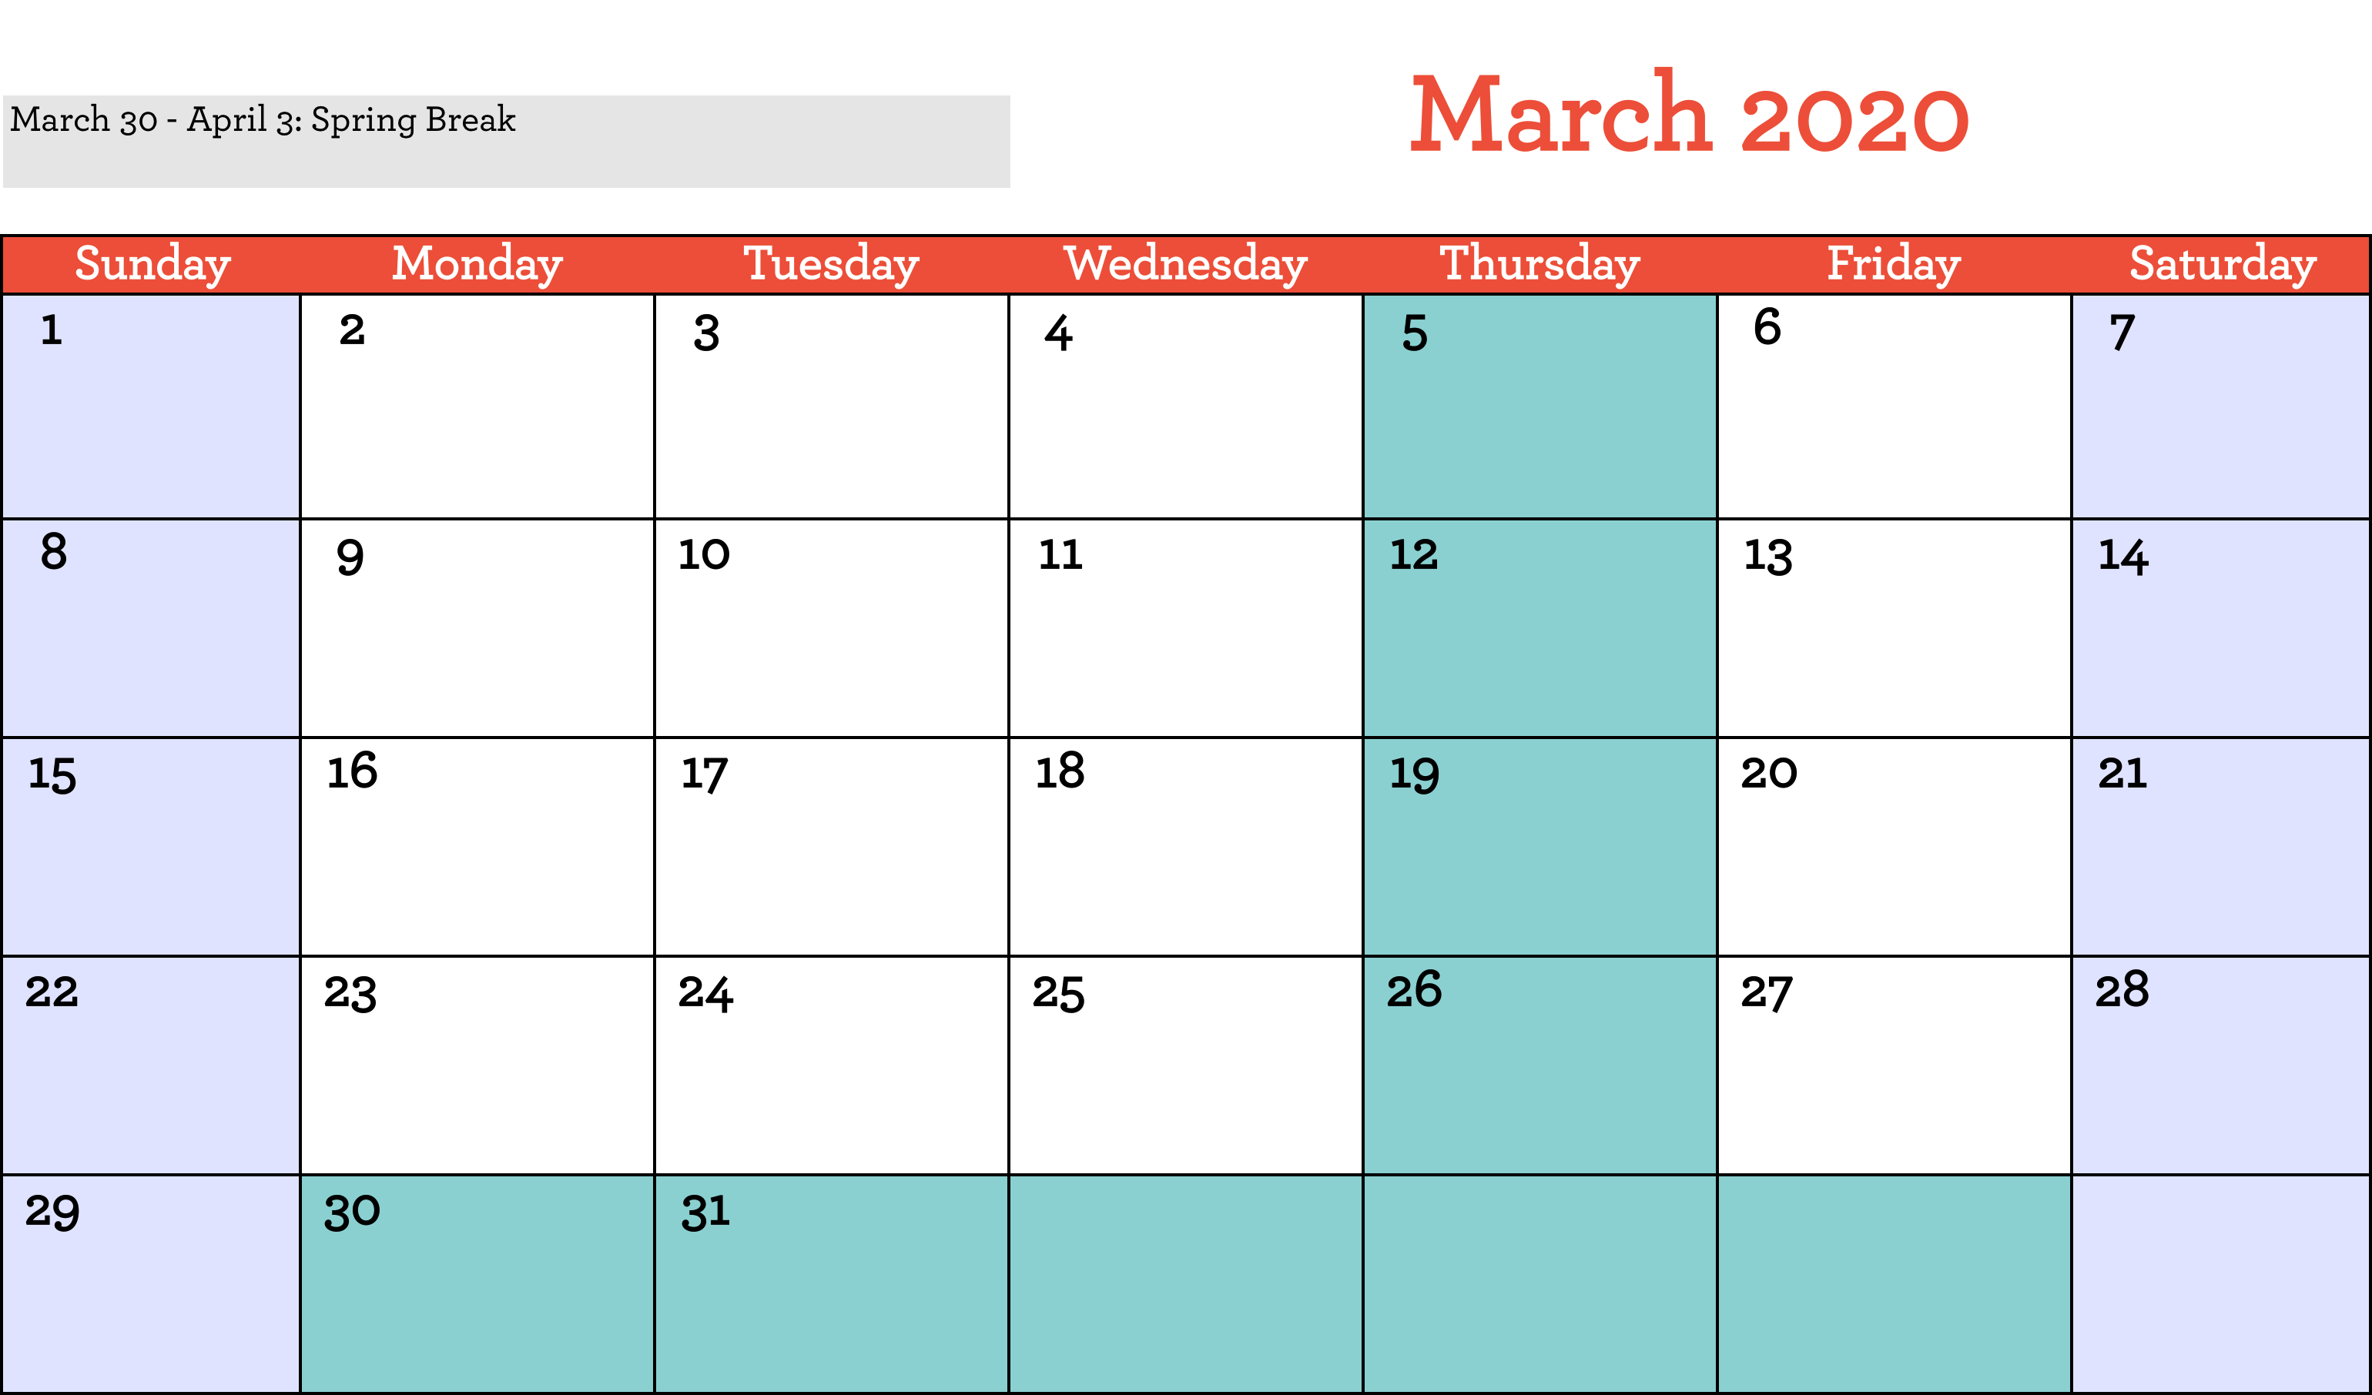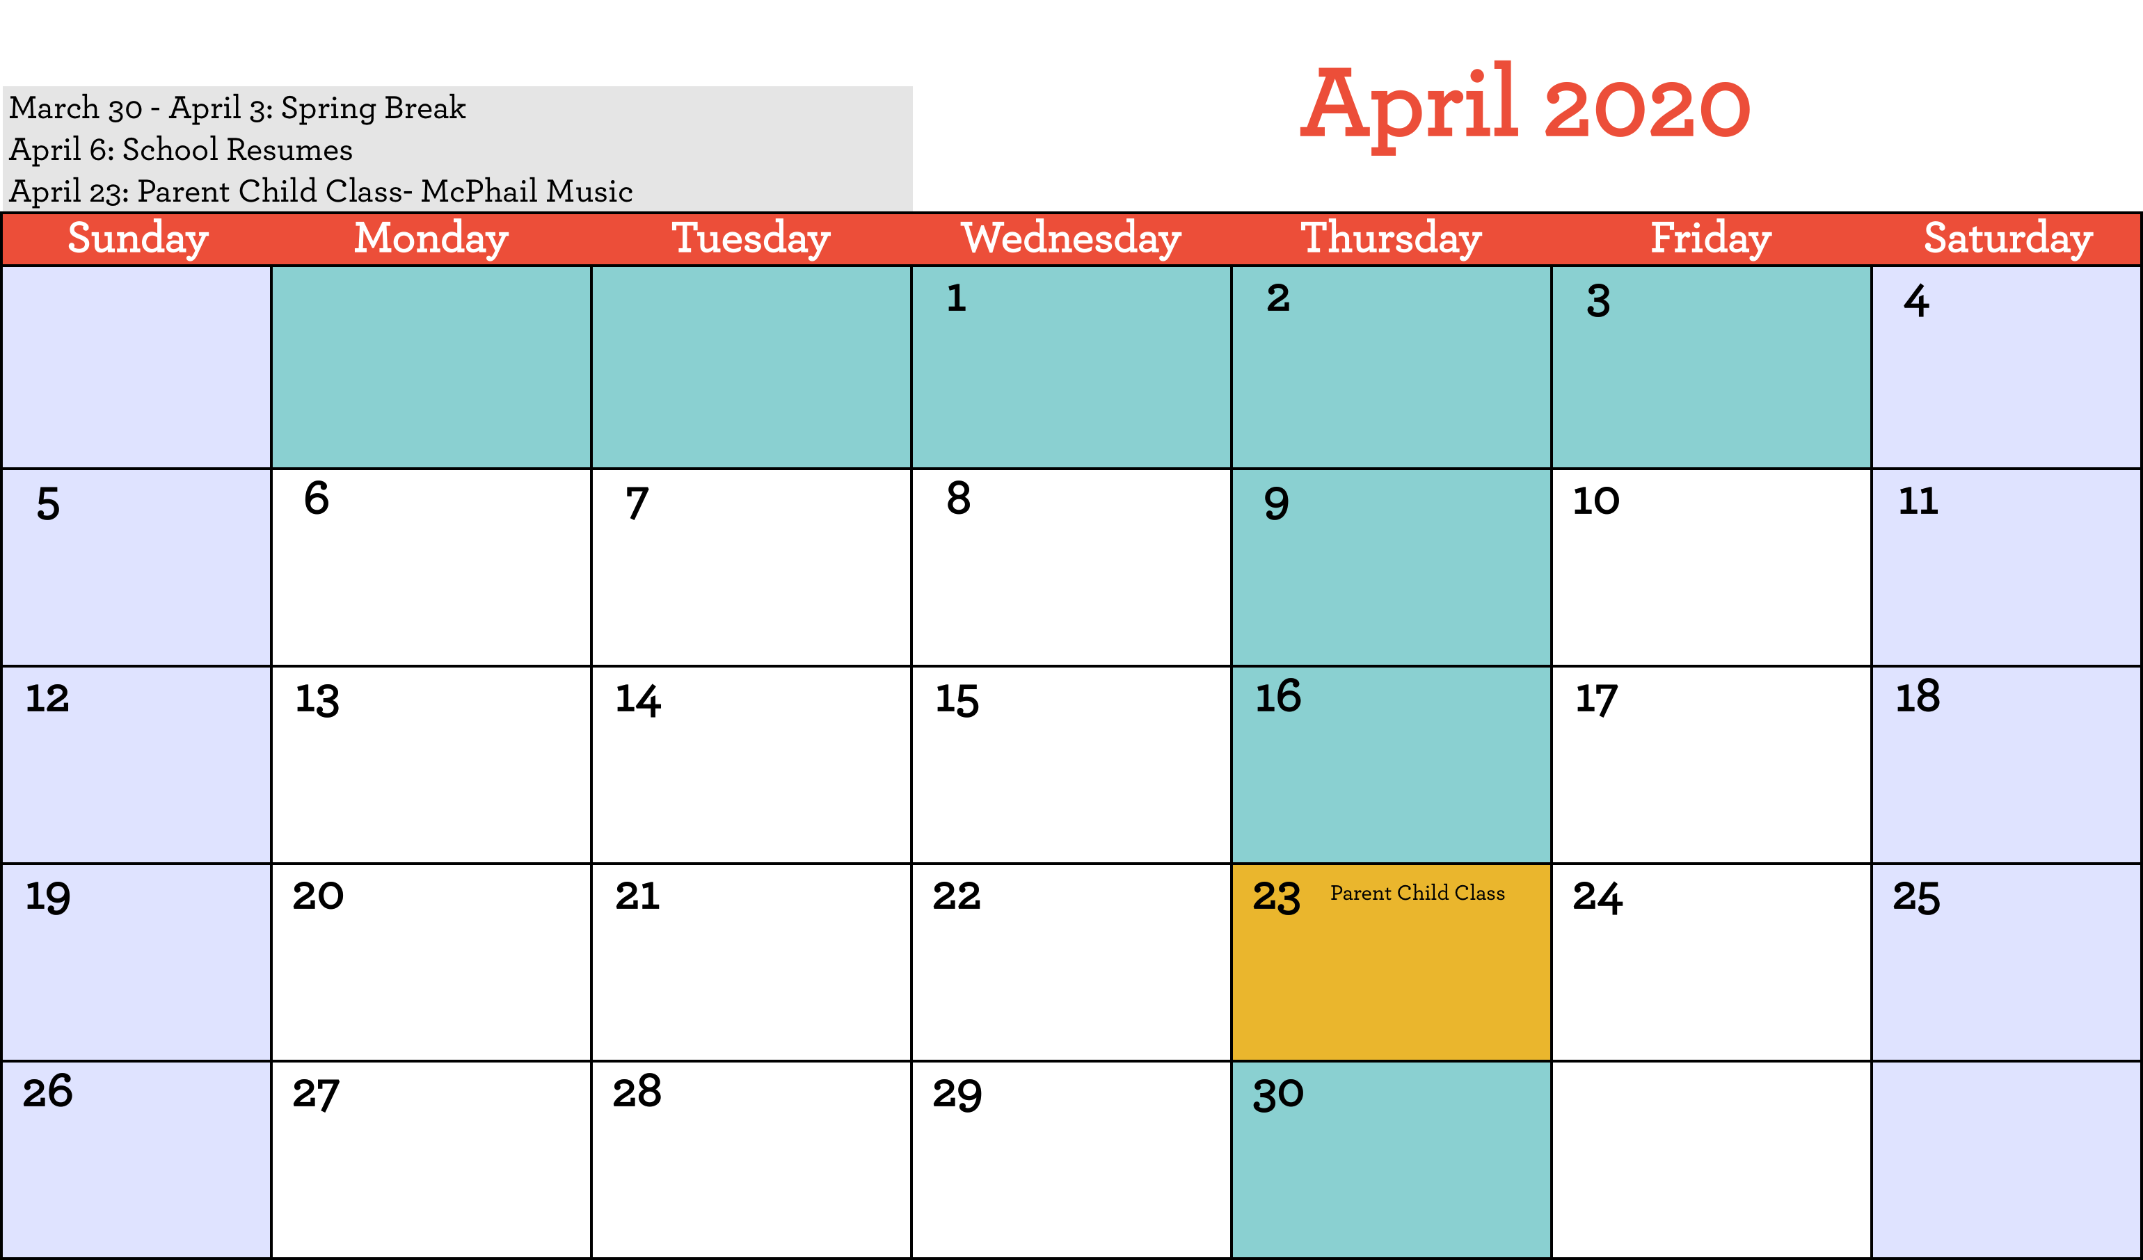

Preschool Pals Staff:

Eka Nagoya, Lead Teacher 612.558.6562

Alanna Welsh, Assistant Teacher

Daniela Brito, Classroom Aide

Willie Lane, Bus Driver

Information:

Way to Grow office: 612.874.4740

Preschool Pals: 612.558.6562

Hours of Operation:

AM class: 8:00 am – 10:30 am

PM class: 12:30 pm – 4:15 pm